Number of livestock farmed organically in the UK, 2019-2022 (thousand head)
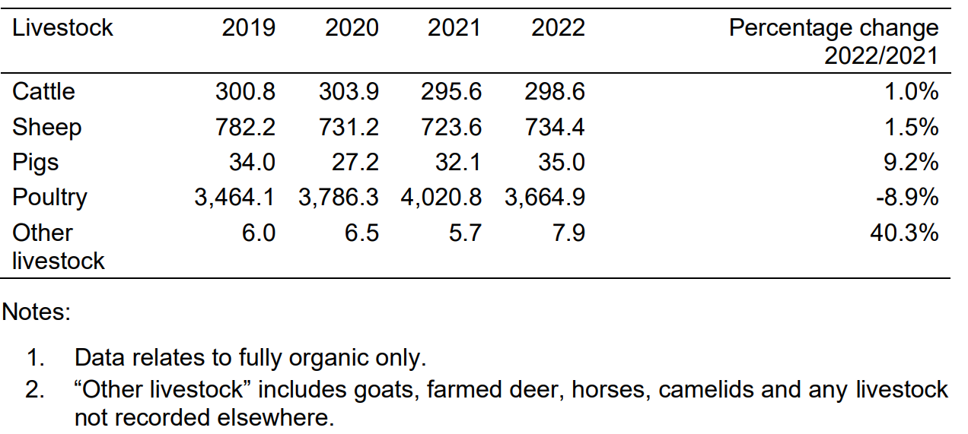

Number of livestock farmed organically in England, 2019-2022 (thousand head)
