Organic livestock numbers in the UK, 2022, (thousand head)
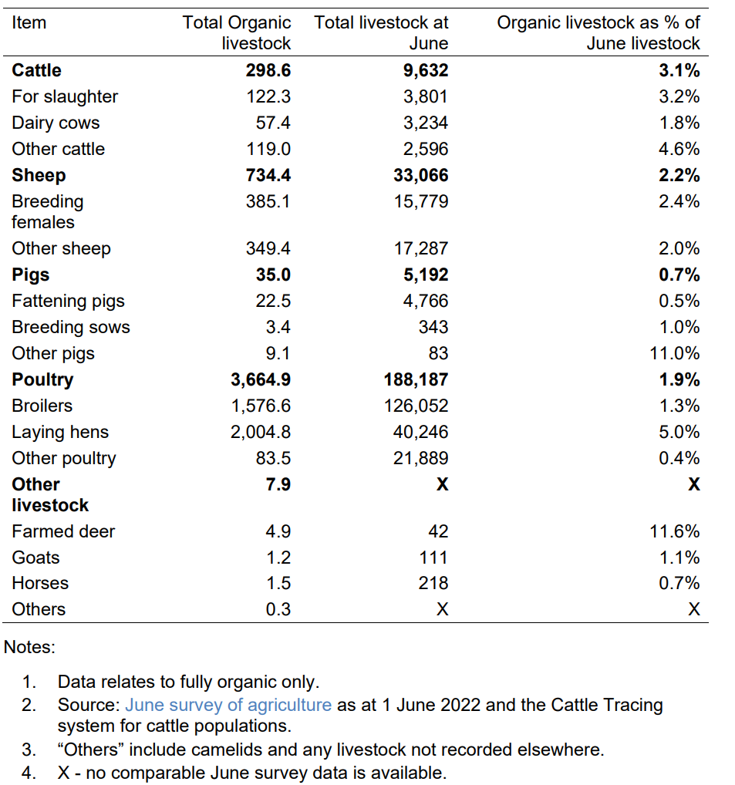

Organic livestock numbers in England, 2022, (thousand head)
