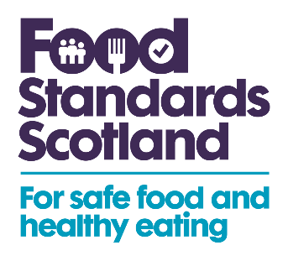

To: All interested parties
30th June 2023
Dear Sir/Madam,

The Feed Additives (Form of Provisional Authorisations) (Cobalt(II) Compounds) (Scotland) Regulations 2023

I am writing to inform you that The Feed Additives (Form of Provisional Authorisations) (Cobalt(II) Compounds) (Scotland) Regulations 2023 (Scottish Statutory Instrument (SSI) No.170) comes into force on the 30th June 2023.

This SSI provisionally authorises four cobalt compounds as feed additives for ruminants with a functional rumen, equidae, lagomorphs, rodents, herbivore reptiles and zoo mammals, in accordance with the specifications in the Schedules of the Instrument and ensures the protection of animal welfare. The four nutritional compounds of trace elements are:

- Cobalt(II) acetate tetrahydrate (ID 3b301)
- Cobalt(II) carbonate (ID 3b302)
- Cobalt(II) carbonate hydroxide (2:3) monohydrate (ID 3b303)
- Cobalt(II) sulphate heptahydrate (ID 3b305)

The provisional authorisations are for three years, starting on the 15th July 2023 and therefore these four feed additives can continue to be placed on the market in Scotland. Entries will be updated on the GB Register of Feed Additives.

The provisional authorisations apply to Scotland only. Separate legislation to allow for the provisional authorisation for these four cobalt compounds has also come into force in England and Wales.

An additional cobalt feed additive (coated granulated cobalt(II) carbonate (ID 3b304)) remains permitted on the market across the UK under its current terms of authorisation until a decision is made on its renewal application.

Under current operating arrangements for Northern Ireland (NI), businesses seeking a new authorisation for a regulated feed product to be placed on the NI market will continue to follow EU rules.

If there are any queries regarding this letter please do not hesitate to contact me.
Kind regards,

Matthew Mullen
Food and Feed Safety Policy
Food Standards Scotland

