Summary of new charging structure for annual subsistence and new Permit applications
– interpreted for feedmills
Annual subsistence charges
The new structure for calculating subsistence charges for permitted sites will be based on a simplified system rather than an Operational Risk Assessment (OPRA) score and complexity calculations. The new charging regime will apply from April 2018. AIC’s Feed Manufacturing Group has been in dialogue with the Environment Agency (EA) ahead of the public consultation, to ensure the feed sector’s interests have been accounted for in the proposals, although some points of clarification are still required.
There are indications that the feed sector, historically highly performing and relatively low risk to the environment compared to other industrial processes, will benefit from the new charging regime. In general, companies should see a reduction in their charges from April 2018. However, if costs beyond the new basic charges are incurred, the EA will charge for time and materials in line with the updated charging structure. As a low maintenance, highly compliant sector, these extra charges will only apply in the event of permit breaches or failure to comply with permit conditions or basic administration requirements.
- New simplified system
Charges will be related to the number of ‘components’ of the process posing a risk to the environment, linked to the compliance cost. For animal feed compounding, generally, it is the component ‘abatement to air’ which will apply.

Therefore, for 2018-19, most companies will be invoiced for one component. A component for odour/noise abatement will only apply if that is a substantiated component of managing the site.

Operators will need to check if other components apply, which may increase annual subsistence charges. (See component description tables in attached EA presentation.)

Number of applicable components | Proposed annual subsistence charge
0 | £3,077
1 | £4,058 (applies to most feedmills for abatement to air)
2 | £5,039
3-4 | £6,510
5-6 | £8,471
7-8 | £15,434
9-13 | £20,533
14+ | £27,986

- Additional charge (not applicable yet)
There will be charges introduced to cater for boilers and generators (to comply with the new Medium Combustion Plant (MCP) regulations) but this will not be applicable for existing plant, until required as part of the Permit condition, in 2024.

For new plant not commissioned before 20th Dec 2018, the additional charge will apply in the charging calculation from April 2019 i.e. not applicable for April 2018 – April 2019.
These charges are still to be confirmed but are proposed as follows:
A single MCP – £390 (most feedmills)
Up to 3 MCPs – £700
Up to 5 MCPs – £950 etc.

- All variations to permits and any related costs will be sector specific. More detail has been requested on the classification of minor, normal and substantial variations etc.

For feedmills (part of the Food and Drink sector) these charges have been proposed:

Minor  variation | Normal  Variation | Substantial variation | Transfer application | Surrender application
£4,195 | £6,992 | £12,585 | £2,459 | £8,390

- The financial advantage of having ISO 4001 etc. will not be recognised in this charging review – but any discount associated with good environmental management systems will eventually be recognised through a separate process which will recognise performance criteria. The EA are still consulting on how this will bolt onto the new charging system.

In the meantime, there will be no changes to the existing Permit Compliance Classification scheme i.e. compliance rating effects on the subsistence charge. These are currently defined by bands A-F as follows:

Compliance classification adjustments based on Permit breaches:
A = 0.95% i.e. 5% reduction for Band A performing companies
B = 100% No change to subsistence
C = 110% 10% increase etc.
D = 125%
E = 150%
F = 300%

- Unplanned costs, will follow time and materials rates see figure 1 below, presuming the responsibility lies with the company concerned. (There is still insufficient information on how charges for handling public complaints will be handled).

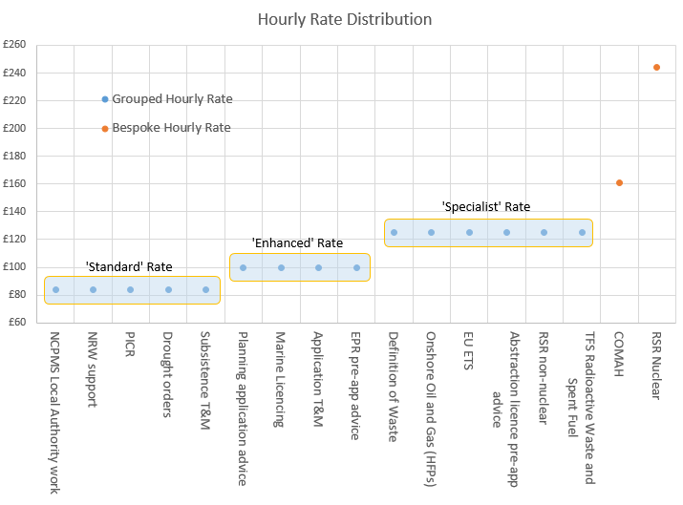
Figure 1:EA Charging rates
New EA Permit application charges
These will be based on the primary activity (animal feed compounding processes, as covered by the Best Available Technology reference documents) not complexities or tonnage calculations, site situation or OPRA, as before. All activities of the feed compounding process (example below) should be termed ‘primary activity’.
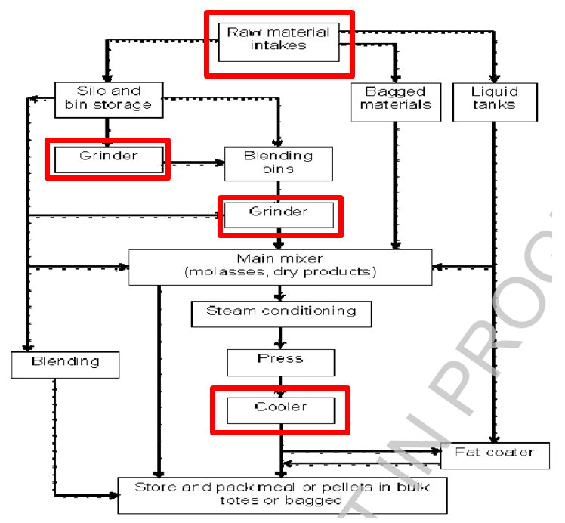
- Therefore for the typical processes i.e. including mixing, grinding, pressing cooling, bagging – a set new application charge will apply - £13,984
- Every ‘copy/mirror’ of that activity will be charged at 10% of this set fee
- A ‘secondary activity’ will attract additional charges at 50% of the primary activity charge
- AIC suggest that all equivalent processes fall into the one fixed charge but we are seeking clarification as to whether, for example, multiple presses, or two separate processes on the same site would be termed as mirror activities; and what would fall under the term secondary activity (CHP plant, production of intermediates, etc.)

